Collier Student Lettings

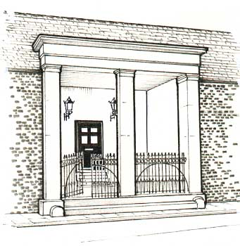
Lansdowne Lodge

94 Greatbridge Road, Romsey, Hampshire, SO51 8FH
Mobile : 07774 883 519

Email: cccollier7@gmail.com
www.collierstudentlets.co.uk

30 September 2019

Dear

Surety for Tenant –

I would like to take this opportunity of introducing myself as the landlord of the house in Southampton in which has chosen to live from September 2019. My children both went to Southampton University in the early 1990s, which is how we got into the letting business. My wife and I are professional landlords and we look after about a dozen properties from our own house in Romsey, which is not far away. We take our responsibilities very seriously and please rest assured that we will look after well while he is in the house.

has given us your name as his guarantor for his rent for Road, Southampton. The rent is paid equally by all the tenants of the house and so his share of the rent will be £ per calendar month unless they decide to apportion the rent according to the sizes of the rooms.

By signing the attached Surety you are guaranteeing to pay the rent for the remainder of the tenancy agreement should fail so to do. You are only being asked to act as his guarantor and not for any of the other tenants in the house. We have never, thus far, been called upon to contact a guarantor.

I would be grateful if you would kindly sign and return by post the attached Form of Surety to me as soon as possible in order that we can confirm the tenancy.

With every best wish

Clive Collier

